# Deployed VMs and Network Settings Report

## Accessing the Azure Portal

Action: Sign in at https://portal.azure.com using your organizational credentials.

## Creating and Configuring Virtual Machines

### Deployment Steps

- Navigate to the Azure Portal and open the Virtual Machines section.

- Click 'Create a new virtual machine' and fill in the required details.

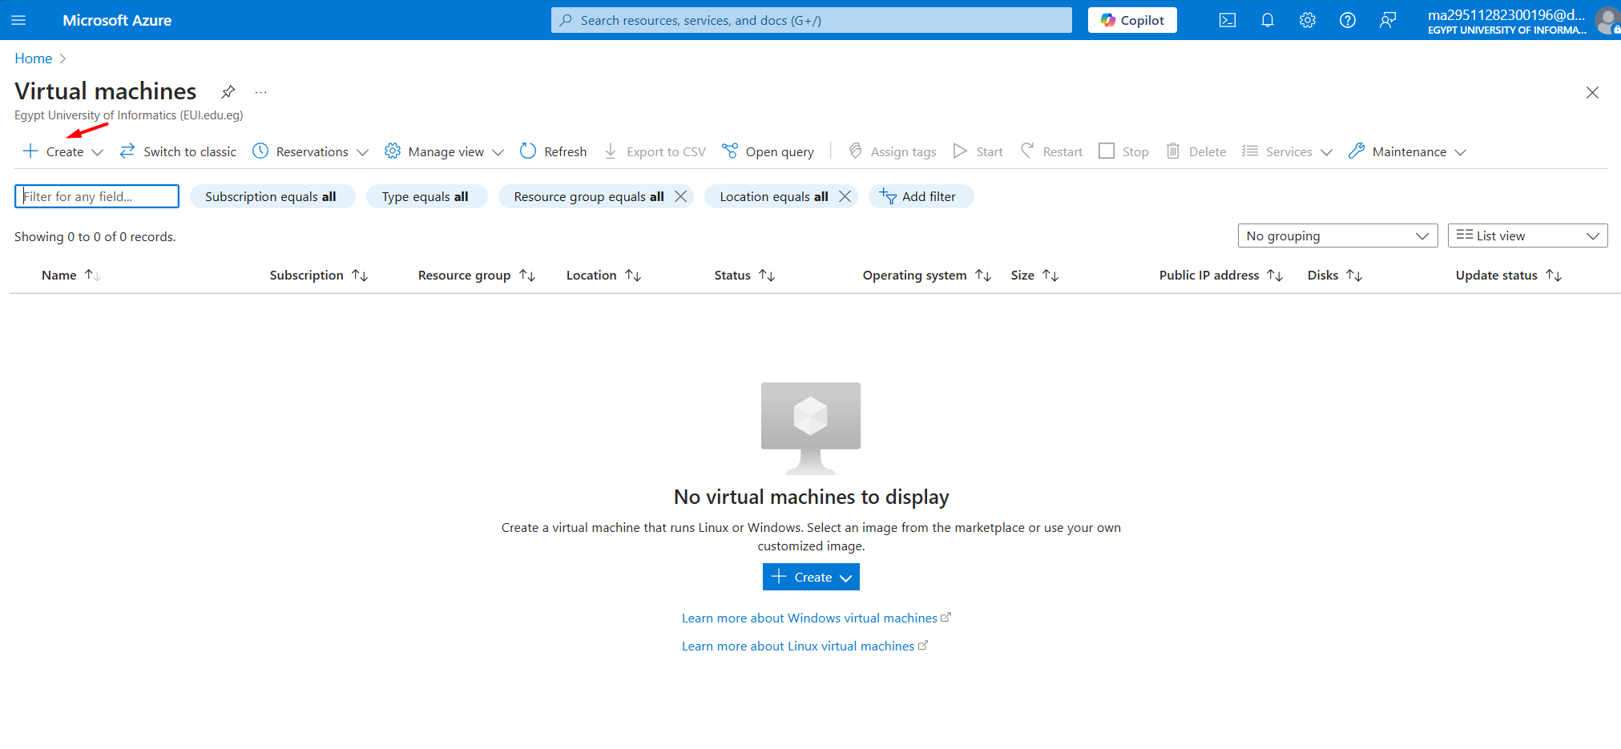

- Choose an OS image and specify the disk type.

- Set up the authentication method and administrator credentials.

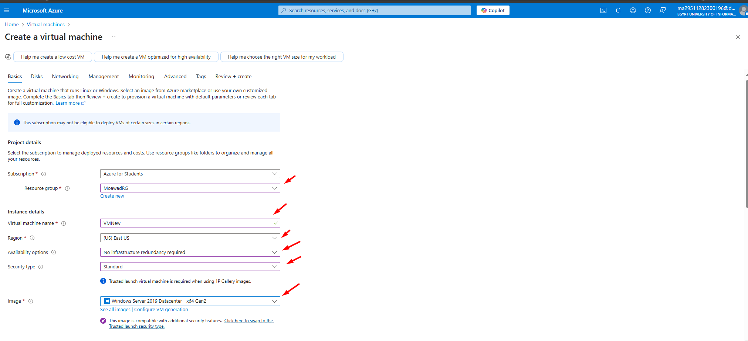  
- Select the VM size based on the workload.

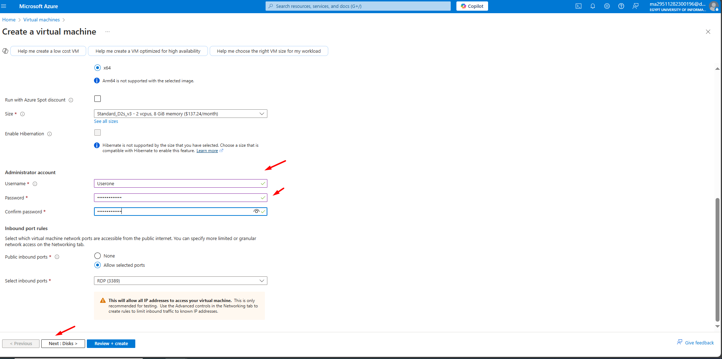  
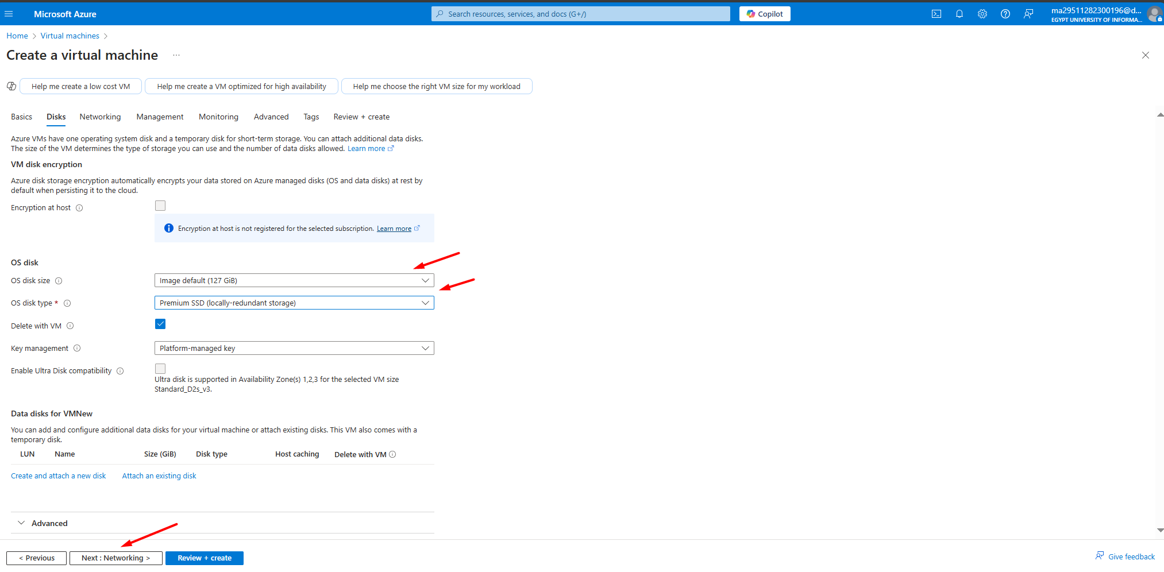  
- Configure networking settings and assign the VM to a virtual network and subnet.

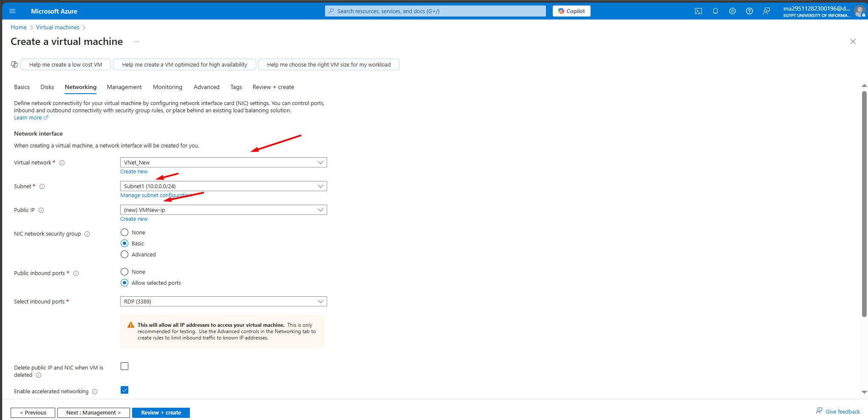

- Review the settings and deploy the VM.

- Validate the VM status once deployment is complete.  
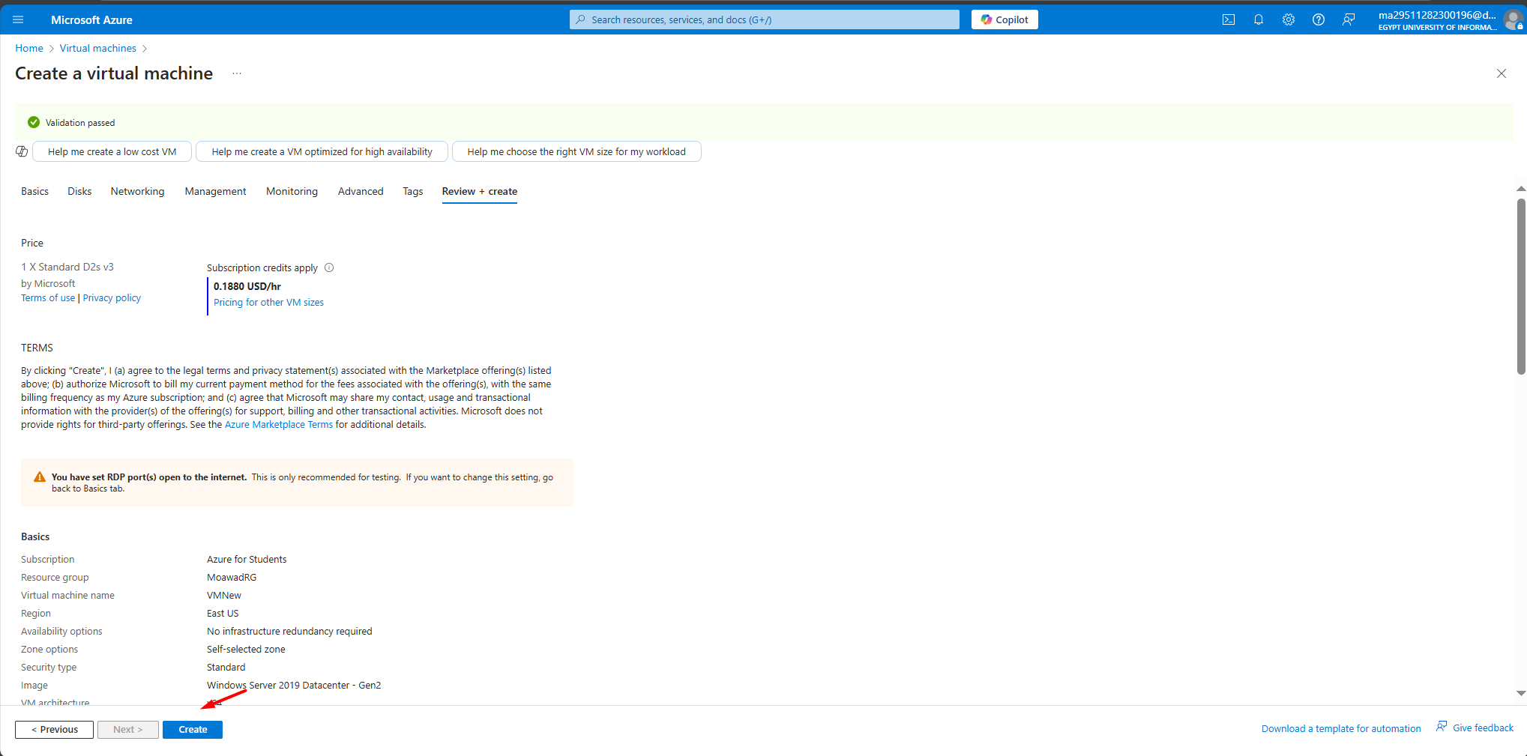

## Network Configuration

Ensure proper network configurations are applied to the deployed VMs.

### Virtual Network (VNet) Configuration

-VNet Name:-Specify the virtual network name.

-Resource Group:Associate the VNet with a resource group.

-Location:- Select the Azure region for the VNet.

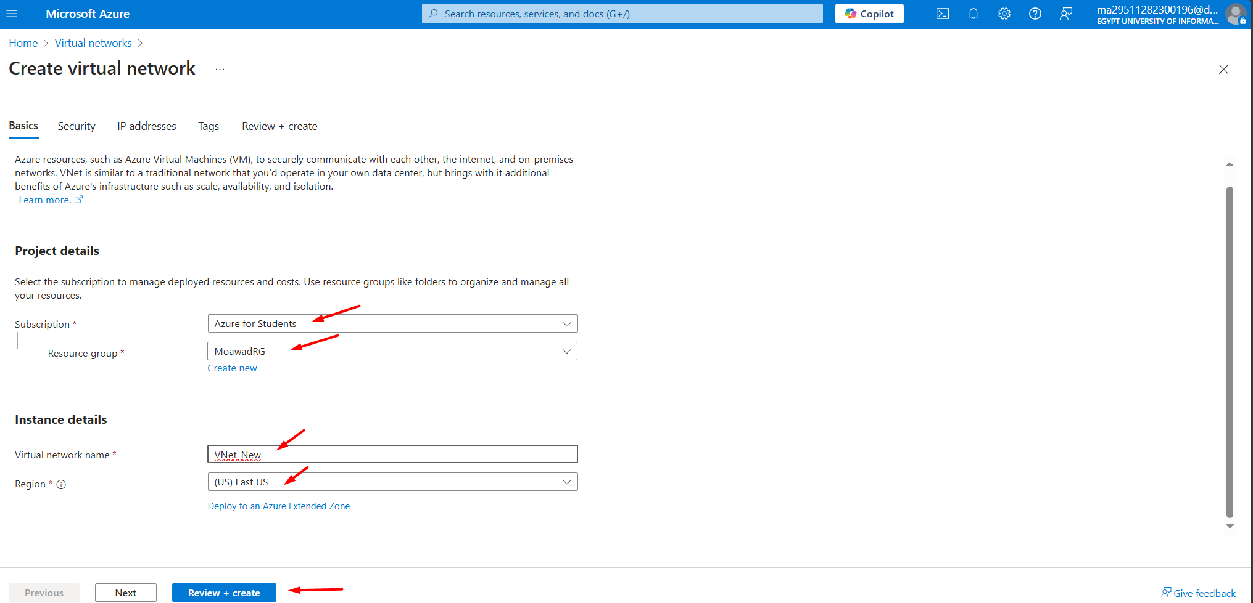

* Address Space: Define the IP address range for the VNet.

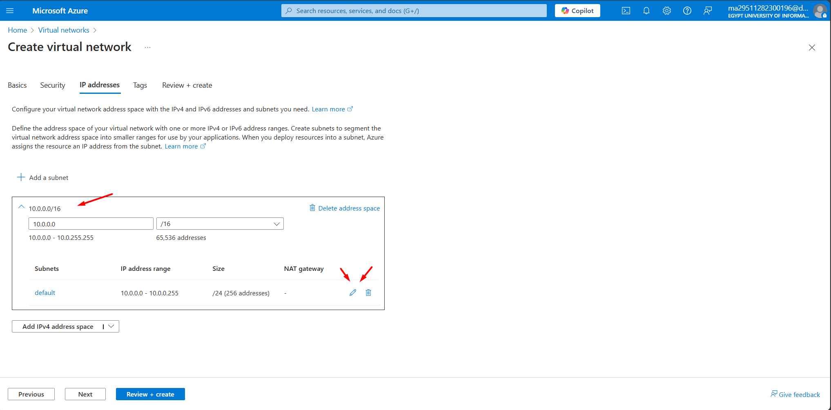

### Subnet Configuration

* Subnet Name:Define the subnet name.
* Address Range:Specify the subnet IP range.

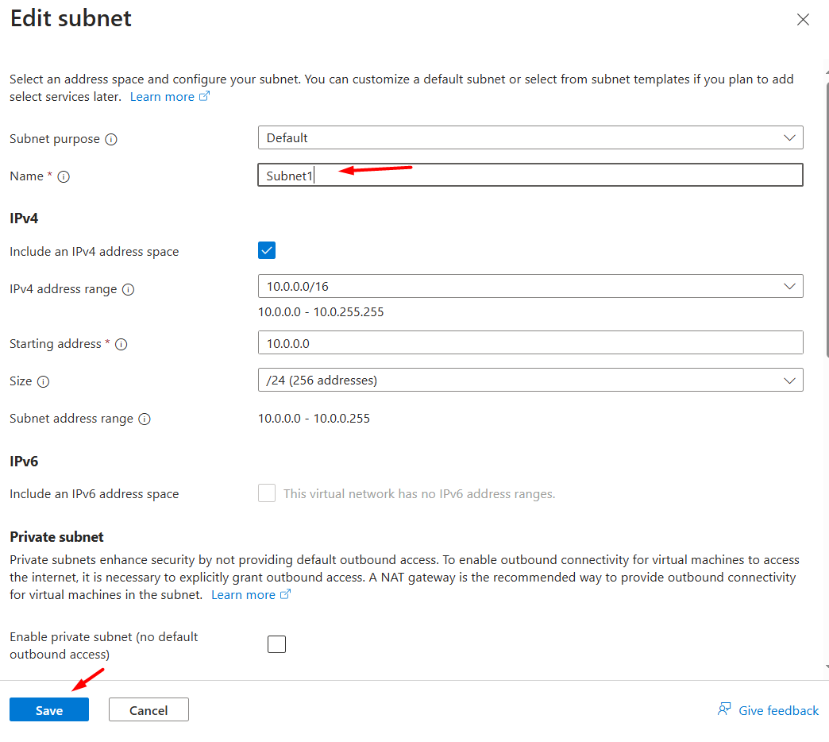

Azure Active Directory Setup Report

1. 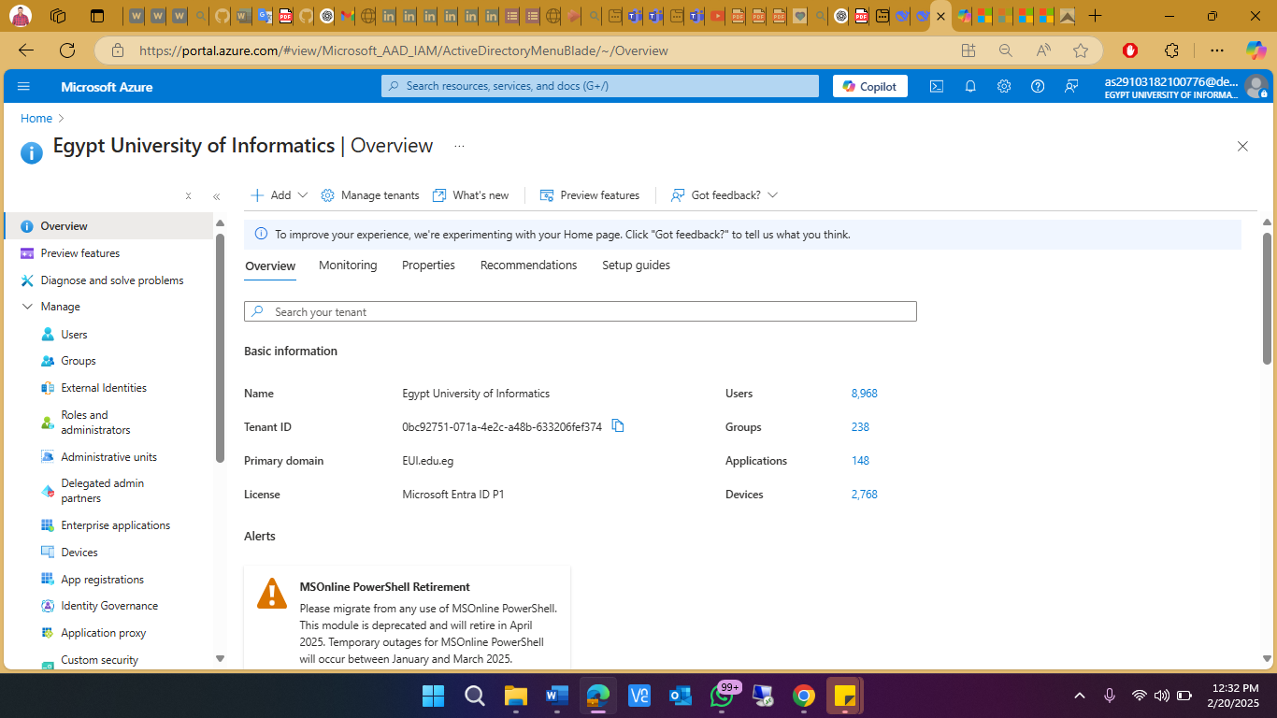**Accessing the Azure Portal**

**Action:** Sign in at https://portal.azure.com using your organizational credentials.

1. **Creating a New Azure AD Tenant**

**Action:** In the left-hand navigation, select **Azure Active Directory** and then choose **Manage tenants** or **Create a tenant**.

**Details:**

Enter your organization’s name.

Provide an initial domain name.

Select your country/region.

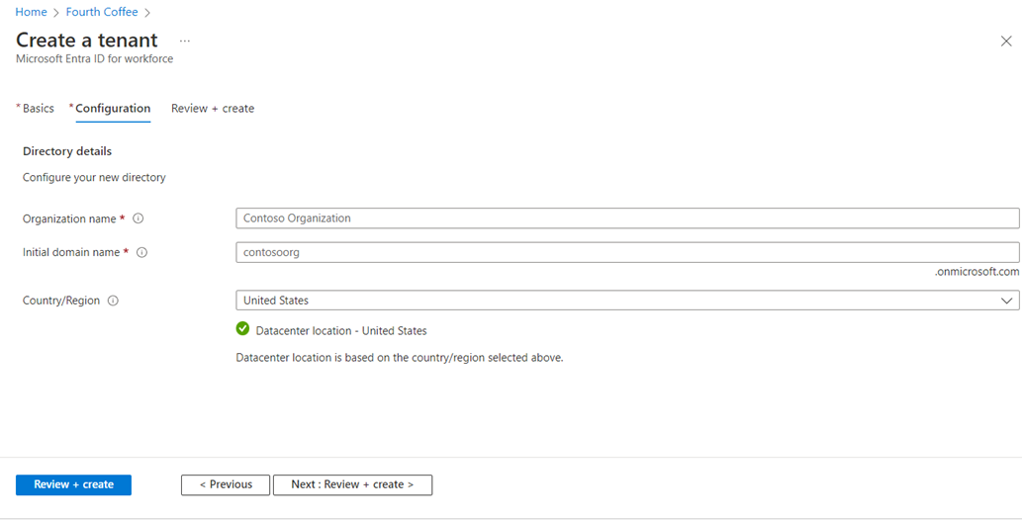**Purpose:** Establish a dedicated directory for identity management.

1. **User and Group Management**

**User Management:**

**Action:** Add users manually or enable self-service sign-up.

**Configuration:** Set up password policies, usage locations, and assign appropriate roles.

**Group Management:**

**Action:** Create groups to streamline permissions management and implement role-based access control (RBAC).

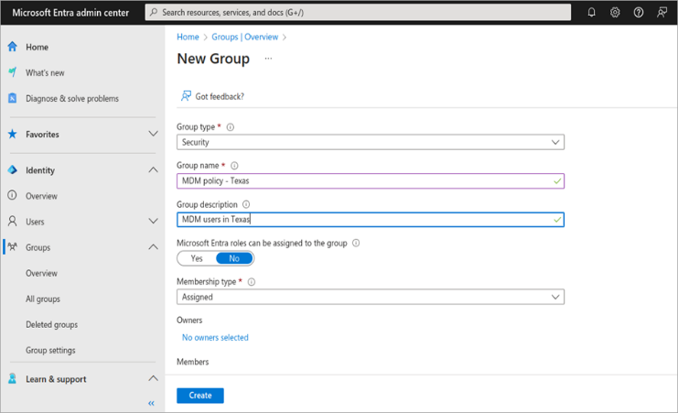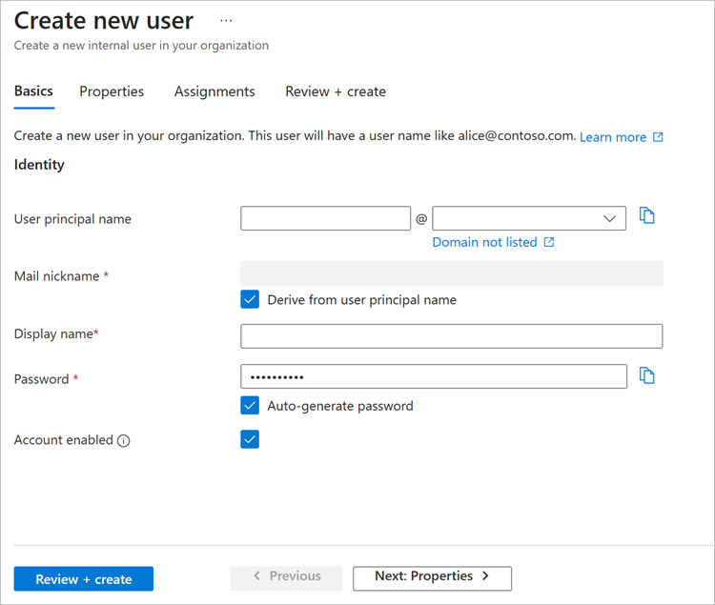**Purpose:** Efficiently manage user access and secure application usage.

**Azure AD Connect: Install and Setup Guide :**

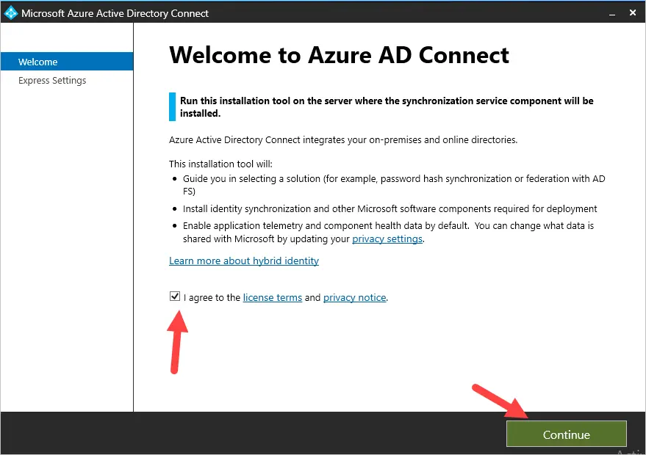**Step 1. Start the Azure AD Connect install**

**Step 2. Choose Installation Type**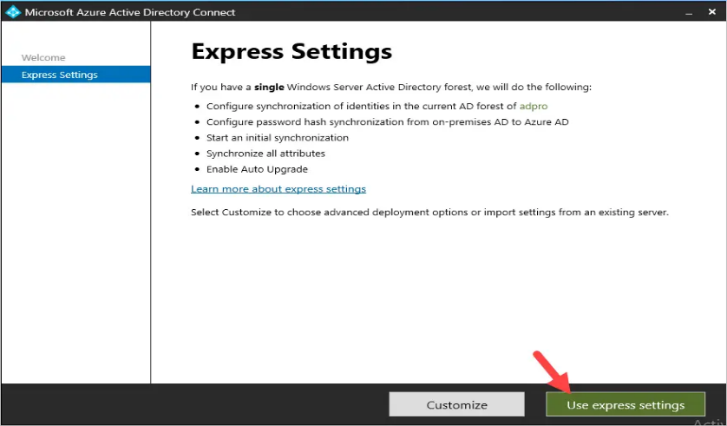

**Step 3. Connect to Azure AD**

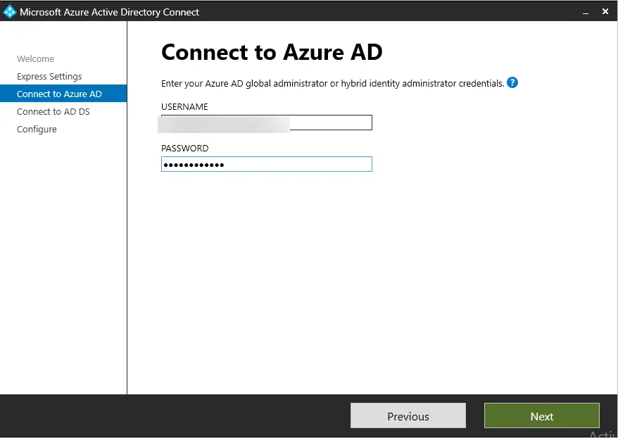Enter the username and password of the Azure AD global administrator

**Step 4. Connect to AD DS (on-premises Active Directory)**

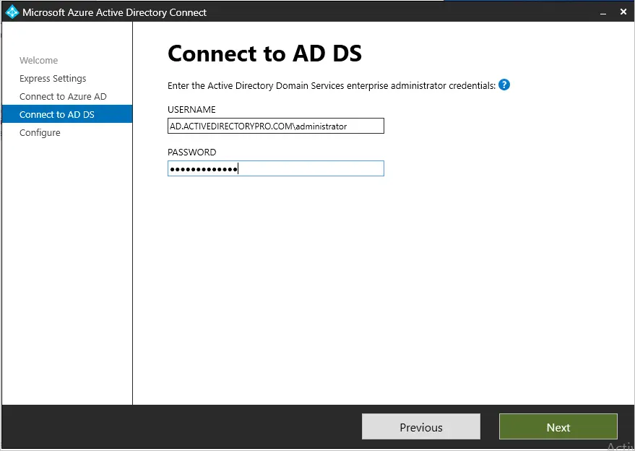Now you will enter the credentials of an enterprise administrator account for your on-premises Active Directory. These credentials are used to create the local Active Directory account that is used for synchronization.

.

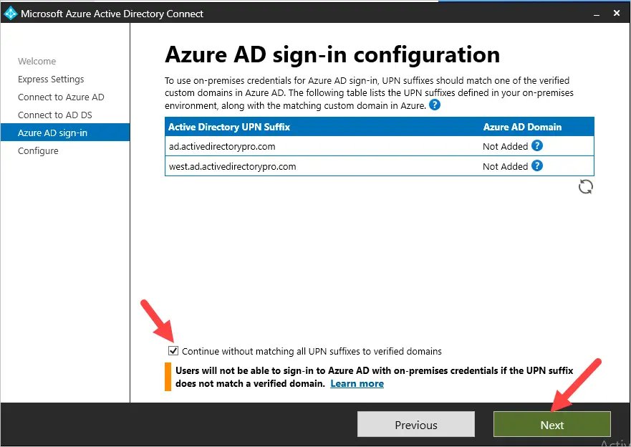**Step 5. Azure AD sign-in configuration**

**Step 6. Ready to configure**

This last step will actually install the Azure AD Connect tool and configure it using the provided settings

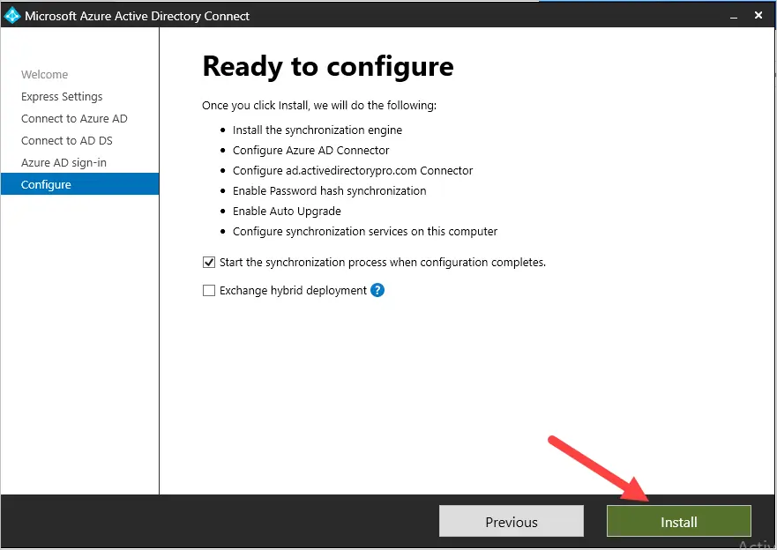

The installation can take several minutes to complete.

